Aquinas Academy of Greensburg
Dress Code Policy, Effective July 1, 2022
Your cooperation is essential in adhering to the school’s established dress code policy.

Uniform Requirements:
Students in Grades K-6 must wear the daily school uniform
Students in Grades K-6 must wear the gym uniform on physical education days

Uniforms can be purchased only at the following vendor:

All Items:
- Log Cabin Embroidery – 724-327-5929
- Logcabinembroidery.com

*Provides Every School Uniform Item Needed*

Disciplinary Actions:
A single abuse of this privilege may result in a dress code referral. Three referrals will result in a detention. Referrals for dress code violations will be sent home as needed. Violations of this code will result in the student not being able to represent the school publicly on the playground, gym, field trips, etc.

Aquinas Academy Boys and Girls Common Dress Code Policies

Shoes/Socks:
- Dress Shoes with Rubber Soled Shoes – Brown, Black or Blue or Conservative Athletic Shoes
- Socks must be worn at all times – Solid White or Navy-Blue Colors Only – No Logos – Must be at ankle length or longer. For girls, tights may be worn in place of socks – Solid Navy-Blue or White Only
- Boots of any type may not be worn in school. Snow boots can be worn to school but must be changed for school shoes prior to the beginning of the day. No crocs, mules (backless shoes), or sandals. Shoes with laces must be tied.

Belts:
- Navy blue or black belt must be worn with all pants

Hair & Accessories:
- Hair styles are to be simple and neat and not obstruct vision.
- Boys’ hair must be completely above the collar of the shirt.
- Bleached or colored hair is not permitted. Mild natural tone highlights in accord with the student’s natural hair color are permitted.
- Ear Piercing is acceptable for girls only. Small earrings are permitted – no dangling earrings. No piercings are acceptable for boys.
- Tattoos are unacceptable.

Physical Education Uniform:
- Physical Education Uniform T-shirt or Long-Sleeved Shirt
- Physical Education Uniform Navy Blue Shorts – right above the knee (front and back) – may be worn in August, September, October, April, May and June ONLY.
- Physical Education Uniform Pants
- Conservative Athletic Shoes

Dress-Down Days:
- Held on special occasions
- Unacceptable Dress-Down Attire includes:
  - Tight-fitting and immodestly revealing clothing
  - Mini-skirts and tops/dresses with off-the-shoulder or low neckline styles
  - Clothing that is ripped, torn, ragged or dirty
  - Short shorts, spandex shorts, tank tops, midriff tops or short tops
  - T-Shirts with rock band advertising, slang, violent pictures, etc.
Students’ dress must reflect the spirit and philosophy of the school. Students are to apply the standard dress code regulations to their casual dress, i.e. Short length, pants at waistline, etc.

Aquinas Academy Girls Uniform Policy

Polo Shirts:
- All Polo Shirts must have the school logo emblem, embroidered by approved vendor
- White or Uniform Carolina Blue Polo Shirts – Long or Short Sleeve
- White Sweaters or Uniform Solid Navy Blue (cardigan/v-neck/crew neck/sleeveless vests)
- Solid white undershirts only permitted under uniform shirt
- Shirttails should be tucked in at all times, unless wearing a banded-bottom shirt

Pants/Shorts:
- Navy Blue Uniform Pants must be worn at the waistline
- Navy Blue Uniform Shorts – right above the knee (front and back) – may be worn in August, September, October, April, May and June ONLY.
- No faded, baggy, tight, or cargo items may be worn

Jumpers/Skirts:
- Uniform Plaid Crew Neck Jumpers
- Uniform Plaid or Navy-Blue Skirt/Skort
- The hemline must be within two inches of knee front and back.

Miscellaneous:
- Make-up is not permitted.
- Scout Uniforms may be worn on Scout meeting days or during Scout Week.

Polo Shirts:

Aquinas Academy Boys’ Uniform Policy

- All Tops must have the school emblem
- Uniform White or Carolina Blue Polo or Button Up Shirts – Long or Short Sleeve
- Solid Navy Blue or White Sweaters (cardigan/v-neck/crew neck/sleeveless vests)
- Solid white undershirts only permitted under uniform shirt
- Shirttails should be tucked in at all times

Pants/Shorts:
- Navy Blue Uniform Pants must be worn at the waistline
- Navy Blue Uniform Shorts – right above the knee (front and back) – may be worn in August, September, October, April, May, and June ONLY
- No faded, baggy, tight, or cargo items may be worn

Miscellaneous:
- Boys must be clean shaven – no facial hair is permitted.
- Scout Uniforms may be worn on Scout meeting days or during Scout Week.

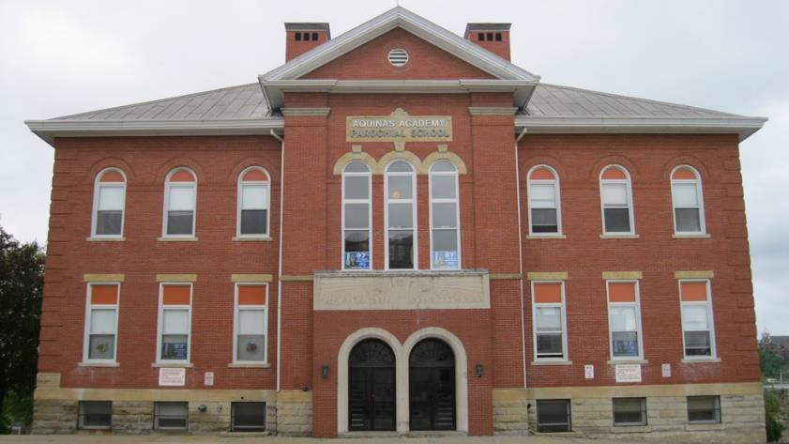
Aquinas Academy of Greensburg 340 North Main Street, Greensburg, Pa., 15601-1811
Telephone: (724) 834-7940

